Yu-Hong Jhuo (Marcus)

yuj0072@arastudent.ac.nz

BCPR301   
Advanced Programming

Assessment 2 Marking Sheet for Coder

Contents

Repository link: 2

Feature list 2

Interface diagram 2

Bad smells before refactoring 3

Refactoring 1 4

Name 4

Location 4

Reasons 4

Strategies/ approaches 5

Result Evaluation 5

Has the bad smell been removed? 5

Did you bring new bad smells into the program? 5

How well is your program now in terms of software quality? 5

Worst bad smells after refactoring1 5

Refactoring 2 5

Name 5

Location 5

Reasons 5

Strategies/ approaches 5

Result Evaluation 5

Has the bad smell been removed? 5

Did you bring new bad smells into the program? 5

How well is your program now in terms of software quality? 6

Worst bad smells after refactoring2 6

Refactoring 3 6

Name 6

Location 6

Reasons 6

Strategies/ approaches 6

Result Evaluation 6

Has the bad smell been removed? 6

Did you bring new bad smells into the program? 6

How well is your program now in terms of software quality? 6

Expected marks 6

# Repository link:

<https://github.com/forestraindrip/PR301_Code_Refactoring.git>

# Feature list

* User can select pen
* User can put pen down
* User can move pen up
* User can move the pen horizontally (go along)
* User can move the pen vertically (go down)
* User can draw a line with input direction and distance
* The system can read commands from text file
* The system can parse the commands from text file

# Interface diagram

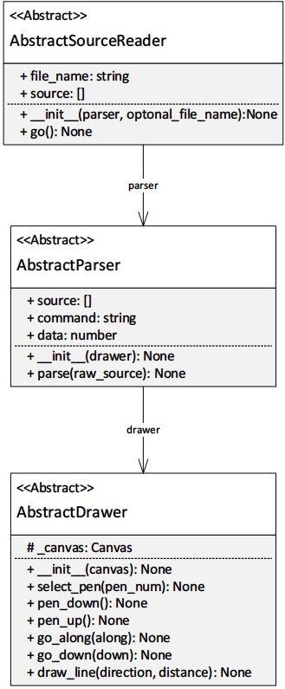

# Bad smells before refactoring

The order of the list is from the worst bad smell to the lesser ones.

* Lazy Class in AbstractSourceReader

Location: tigr.py => AbstractSourceReader => line 51~64

* Inappropriate Intimacy between frontends and parsers

Location: front_end_kieran.py => TkinterInterface => draw() => line 71

front_end_jerry.py => GuiInterface => draw() => line 64

* Shotgun Surgery in the drawers and frontends

Location: drawer_jack.py => line 7~13, 66

drawer_kieran.py => line 11~17, 55

drawer_turtle_jack.py => line 8~14, 19

all frontend classes

* Alternative Classes with Different Interfaces in two frontends.

Location: front_end_kieran.py => TkinterInterface

front_end_jerry.py => GuiInterface

* Switch statement in the drawers and the parsers.
* Refused-bequest in MainTIGr.
* Long methods in frontends

# Refactoring 1

## Name

Lazy Class

## Location

* refactored_code
  + source_reader_kieran.py
    - Whole MainTIGr class
* tigr.py
  + AbstractSourceReader line 48~62

## Reasons

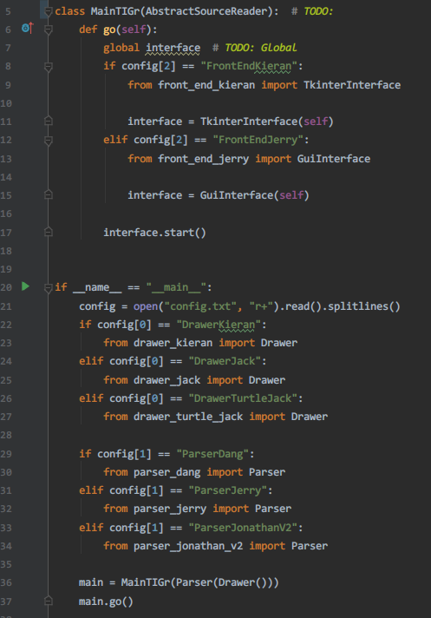

The AbstractSourceReader is the lazy class. As shown in the screenshot, the MainTIGr inherits the AbstractSourceReader. However, there should not be a relationship between them. In assignment 1, the responsibilities of provided abstract class, AbstractSourceReader, is reading source file then passing the result to the parser for further processing. However, in this case, MainTIGr is used as the entry point of the program which distorts the role of AbstractSourceReader. As a matter of fact, AbstractSourceReader has no actual functionality in the program which essentially makes it a **Lazy Class**. Moreover, the current system distributes the function of reading file into multiples frontend classes which **creates other bad smells including** **inappropriate intimacy, shotgun surgery and refused-bequest**. Therefore, I think the Lazy Class of AbstractSourceReader is the most critical bad smell at this stage.

## Strategies/ approaches

* Break the relationship between MainTIGr and AbstractSourceReader.
* Implement a proper SourceReader for source reading.
* Rename the drawers. Three drawers with different implementation sharing the same name before refactoring.
* Rename the parsers. Three parsers with different implementation sharing the same name before refactoring.
* Redirect the functions needing source reading to the new SourceReader.

## Result Evaluation

### Has the bad smell been removed?

Yes

### Did you bring new bad smells into the program?

No, only a new SourceReader is created. It is a well-behaved source reader absented from the original system.

### How well is your program now in terms of software quality?

* Low coupling: The classes, including drawers, source reader and GUI, have lower coupling now.
* No global variable: The refactoring removes the global variable “interface” in the MainTigr class.
* Separated responsibilities of classes: The frontend classes don’t have the responsibility of SourceReader now. The SourceReader is not used as entry point anymore as well.

## Worst bad smells after refactoring1

* Alternative Classes with Different Interfaces in two frontends
* Duplicate code in frontends, drawers
* Switch statement in the drawers and the parsers
* Long methods in frontends

# 

# Refactoring 2

## Name

Alternative Classes with Different Interfaces

## Location

* refactored_code
  + front_end_jerry.py
    - GuiInterface whole class
  + front_end_kieran.py
    - TkinterInterface whole class

## Reasons

These two frontend classes have similar functions with different implementations and names. Parts of them have duplicate codes which decreases code readability.

## Strategies/ approaches

1. Extract Superclass: Create a superclass AbstractFrontEnd which inherited by two classes

## Result Evaluation

### Has the bad smell been removed?

Yes

### Did you bring new bad smells into the program?

No.

### How well is your program now in terms of software quality?

* Code consistency is increased.
* Code readability is increased.
* Code duplication is greatly reduced.

## Worst bad smells after refactoring2

* Long methods in frontends
* Switch statements in parsers and drawers

# 

# Refactoring 3

## Name

Long methods

## Location

* refactored_code
  + front_end_jerry.py
    - GuiInterface
      * init_widgets() line 19~79

## Reasons

The method has 60 lines. This make the code hard to read and maintain.

## Strategies/ approaches

* Extract Method: Migrate pieces of code into several methods and give these methods meaningful names.
* Further using extract method: To reduce duplication between the derived methods from the previous step.

## Result Evaluation

### Has the bad smell been removed?

Yes

### Did you bring new bad smells into the program?

No

### How well is your program now in terms of software quality?

* Code readability is increased.
* Code duplication is greatly reduced.

# 

# Expected marks

1. Smell detection

* Identification of bad smells: 3*1 marks
* Location of bad smells: 3*1 marks
* The reasons: 3*1 marks
* Descriptions of strategies: 3*1 marks

Total: 12 marks

1. Refactoring
   * Identification of the worst smell: 3*1 marks
   * Version control: 3*1 marks
   * Modification and validation: 3*2 marks
   * Testing and evaluations: 3*1 marks

Total: 15 marks

Overall: **27 Marks**